Future Skills Questionnaire (FSQ) Detailed Report
Data Analysis & Action Plan

INSTITUTION NAME
YEAR GROUP
QUESTIONNAIRE TYPE COMPLETED

Step 1: Review FSQ Detailed Report

Using the Detailed Report and comparison functionality, identify individual learners or groups of learners who need additional support.

Group comparisons:

GROUP COMPARISON | OBSERVATIONS
Gender (male vs female)
Pupil Premium (PP vs non PP)
SEN (SEN vs non-SEN)

Step 2: Record insights using report filters

Use the Detailed Report filter functionality to explore specific criteria, for example:

Less than 50% answered positively: Highlight any questions where fewer than half of the group responded positively
Less than 25% answered positively: Focus on significant areas of concern
Lowest scoring questions: Identify the questions with the lowest percentage of positive responses overall

Now use the Bar Graph to compare responses across groups (Gender, PP, SEN).

Look for discrepancies between groups (e.g. do girls score significantly lower on confidence-related questions compared to boys? Are PP learners less familiar with trusted career websites than their non-PP peers?)

Step 3: Summarise Disparities and Common Needs

Use the space below to highlight any key gaps or differences you have observed:

Step 4: Plan interventions and next steps

Based on your observations, outline targeted actions for each group of learners, or individual learners, who require additional support. Describe how these interventions will address their needs.

GROUP INTERVENTION | TARGETED ACTIONS
Gender (if applicable)
Pupil Premium (if applicable)
SEN (if applicable)

INDIVIDUAL LEARNERS | PLANNED SUPPORT AND TARGETED ACTIONS
Enter name or initials
Enter name or initials
Enter name or initials

To add a new row, hover your mouse in the row above, right-click your mouse, go to ‘insert’ > ‘insert rows below’.
Review the ‘Number of learners who responded to the questions mostly negatively, mixed or mostly positively’ bar chart, enter the information below:
TOP TIP
Click on a question in the ‘Question by question analysis’ bar chart to identify the names of learners who answered the question positively or negatively.
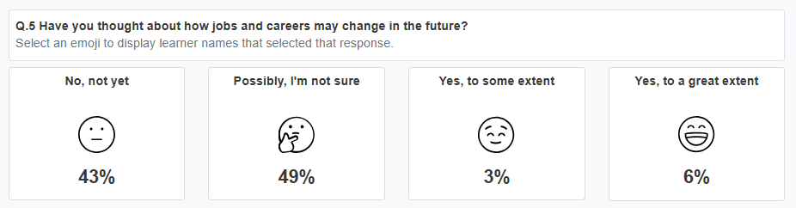
RESPONSES | CAREERS KNOWLEDGE  AND SKILLS | ESSENTIAL SKILLS FOR  LIFE AND WORK
How many learners have answered ‘Mostly Positive’
How many learners have answered ‘Mostly Negative’
How many learners have answered ‘Mixed’

Click on the bar to show learner names.
Consider creating a Custom Group for learners who answered mostly negative, then record targeted activities for these learners directly into Compass+.

Step 5: Review careers programme

Based on the data insights, outline adjustments to the careers programme for next term/next academic year.

ACTIVITIES PLANNED  List any immediate changes (e.g. a workshop on interview skills, introducing Careers Ambassadors) | EXPECTED IMPACT  Describe how these changes aim to  improve specific areas of FSQ

Long-term adjustments:

CURRICULUM CHANGES  Note any planned revisions to career learning, curriculum planning/delivery, partnerships etc | EXPECTED IMPACT  Outline how these adjustments will contribute towards better FSQ outcomes in the future

Step 6: Evaluate the impact of your planned adjustments

FSQ delivery: Specify the date for the next FSQ session to assess progress

Additional data: List any other forms of data (e.g. learner feedback, progression data) that you will engage with to evaluate the impact of your planned adjustments
Evaluation notes: Use the space below to keep a record of your observations and identify any further adjustments needed

